How to convert degrees to radians or radians to degrees.

What are 'radians' ?
One radian is the angle of an arc created by wrapping the radius of a circle around its circumference.
In this diagram, the radius has been wrapped around the circumference to create an angle of 1 radian. The pink lines show the radius being moved from the inside of the circle to the outside:
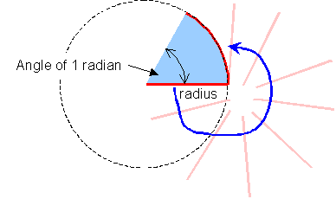
The radius 'r' fits around the circumference of a circle exactly 2π times. That is why the circumference of a circle is given by: circumference = 2πr
So there are 2π radians in a complete circle, and π radians in a half circle.

Converting radians to degrees:
To convert radians to degrees, we make use of the fact that π radians equals one half circle, or 180º.
This means that if we divide radians by π, the answer is the number of half circles. Multiplying this by 180º will tell us the answer in degrees.
So, to convert radians to degrees: 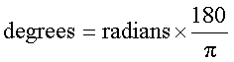
Converting degrees to radians:
To convert degrees to radians, first find the number of half circles in the answer by dividing by 180º. But each half circle equals π radians, so multiply the number of half circles by π.
So, to convert degrees to radians, multiply by ^{π}/₁₈₀, like this: 